California State University, Sacramento
The College of Engineering and Computer Science

CPE 166 Advanced Logic Design

Midterm

Fall 2020

Student Name: Xavier Howell

- [23 points]. (1). Write the Verilog program for the following combinational circuit.
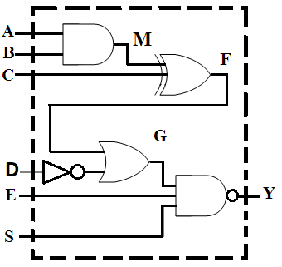

module cir1 (A, B, C, D, E, S, Y );

input _A,B,C,D,E,S_______________________________;

output __Y______________________________;

wire __M,F,G_______________________________;

assign M = __A&B__________________________ ;

assign F = ___M^C_________________________;

assign G = ____F|D_________________________;

assign Y = ____~(G&E&S)_________________________;

endmodule

(2). Complete the testbench for the above circuit to generate testing cases for all possible values of A, B, C, D, E, and S.

module tb;

____reg_____ A, B, C, D, E, S;
____wire_____ Y;
____int_____ i;

____cir1 cir2(.a(a0), ….., .y(y));
initial
begin
{ A, B, C, D, E, S } = ____________________ ;
for ( i=0; i < ___________; i=i+1)
begin
#5 ________________________;
end
#5 $stop;
end
endmodule

2.[27 points] Use Verilog hierarchical design method to design the following circuit.

1). Design clock rising edge triggered 1-bit D FlipFlop with asynchronous reset.
module dff (D, clk, reset, Q);
input __clk,D,reset_____________________;
output ___Q__________________;
reg ___Q____________________;

always@( posedge clk_______________ or _____posedge reset_______________ )
begin
if (reset)
____q<=0_____________;
else
_____q<=d____________;
end
endmodule

2). Use dff above to implement the following circuit and complete the Verilog design.
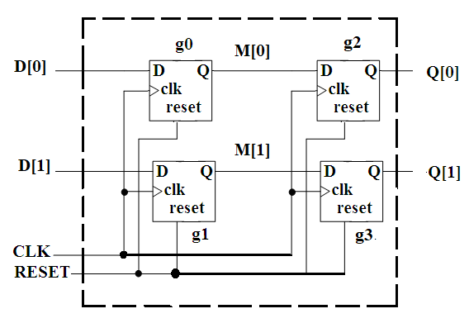
module cir2 (D, CLK, RESET, Q);
input ___D[0],D[1] _______________;
input ____clk,reset______________;
output ____Q[0]_______________;
wire _____Q[1]______________ ;

dff g0( .D(D[0], .Q(M[0]), .clk(clk), .reset(reset));

dff g1( .D(D[1], .Q(M[1]), .clk(clk), .reset(reset));

dff g2( .D(M[0]), .Q(Q[0]), .clk(clk), .reset(reset));

dff g3( .D(M[1]), .Q(Q[1]), .clk(clk), .reset(reset));

endmodule

3. A finite state machine is described using a state diagram shown below.
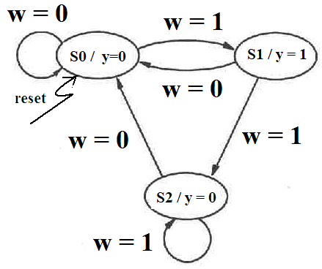

Write the complete Verilog code for the above finite state machine.

module fsm (reset, clk, w, y );  input reset, clk, w;  output y;  reg y;  parameter  s0=2’b00, s1=2b’01;s2=2b’10;  reg [1:0] cs,ns;  always@(posedge clk or posedge reset)  begin  if reset  cs <= s0;  else  cs <= ns;  end  always@(cs or w)  begin  case(cs)  s0: if(w)  ns<=s1;  else ns<=s0;  s1: if(w)  ns<=s2;  else ns <= s0; | s2: if(w)  ns<=s2;  else ns <=s0;  default:  ns=s0;  endcase  end  alawyas@(cs 0r w)  begin  case(ns)  s0: y=0;  s1: y=0;  s2: y=1;  default: y=0;  endcase  end  endmodule

4. [20 points] Complete the following circuit design in VHDL.

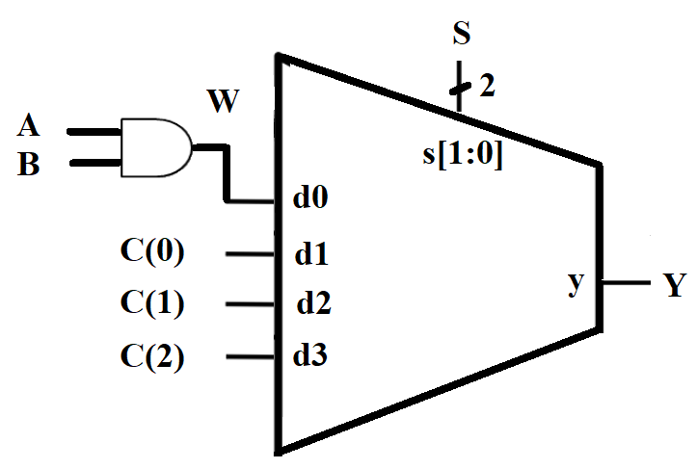

Library ieee;

Use _ieee.std_logic_1164.all;

entity cir4 is
Port ( A, B: in std_logic;
C: in std_logic;
S: in std_logic
Y: out std_logic);
End cir4;

architecture design of cir4 is

_____signalW: std_logic;

Begin

W <= _A and B______________________________;

Y <= _______________ when _____________ else

________________ when _____________ else

________________ when _____________ else

________________ ;

end design;

